Minutes of the Second Meeting on Implementation and Monitoring Committee on MOOCs Content

Chaired by Prof. Bhaskar Ramamurthi, Director, IIT, Madras held on 4th May 2015

at India Habitat Centre, Lodhi Road, New Delhi 110 003

Chairman Prof. Bhaskar Ramamurthi welcomed all the members. The list of all those who attended the meeting is attached in Annexure 1.

A list of courses developed already under NPTEL, CEC, CDAC and lab experiments under Virtual Labs by IIT Delhi and its partners which can be potentially offered or repurposed for MOOC were provided by the respective coordinators. The Chairman thanked all the groups for their quick response. In addition, subjects for offering MOOC titles in the area of Agriculture, medicine/para and pre-clinical courses and training modules were given by Prof. Prabhakar in consultation with the Agri team, AIIMS, and CDAC members. UGC gave the list of all current on-campus vocational programmes and discipline coordinators currently working with faculty throughout the country for creating 15 Semester-long courses in each of eighty disciplines under the E-pathsala programme of NMEICT.

The following items were considered and discussed in detail. The recommendations of the Committee are given as follows:

1. A Sub-Committee was constituted with Prof. R. C. Kuhad, Vice-Chancellor, Central University of Haryana with Prof. Mangala Sunder, IIT Madras, Prof. Hari Babu, Central University Hyderabad and Dr. Rajbir Singh, Director, CEC as members. The Chairman may co-opt other members to his committee. **This Committee would interact with all content developers under NMEICT and give a list of courses that would be readily offered in a MOOC platform from July, 2015 and those courses whose repurposing would be complete before Nov. 2015 so that they can be launched in Jan. 2016**. In addition, the Committee would continue to meet and provide the subjects that need to be developed new, but with online-delivery and credible certification for the next two years. All areas such as arts humanities, social, physical and biological sciences and engineering, law, business and management, agriculture and medicine are to be covered. However since engineering and physical sciences have been covered extensively in NPTEL, the focus will be on remaining areas. NCERT and CBSE would be co-opted to the National MOOCs programme and would give their list of courses. The format for providing the course details will include the following details:
   1. Course title and faculty name(s) with affiliation
   2. Syllabus (to be provided in a uniform format)
   3. Duration and Commencement date
   4. TA details
2. **Virtual labs will continue to be offered as open online learning resources** and the team would work with several representative Universities to map laboratory programmes in engineering and pure sciences for helping students and teachers to improve their practical skills and for better understanding of concepts. A mapping with current NPTEL courses would be provided.
3. The Chairman requested Prof. Mangala Sunder, NPTEL coordinator, Prof. T. V. Prabhakar, IIT Kanpur and Prof. Phatak, IIT Bombay **to give the list of completed and on-going MOOC courses** and user statistics as soon as possible.
4. **The chairman would schedule a meeting with the Secretary, Higher Education who is also the Chairman for the Project Advisory Board of NMEICT, for requesting UGC and AICTE to actively adopt MOOC offerings approved by this Committee on a national scale**. Specifically this means mapping of syllabus, mapping of subject matter expert availability, identifying the relevant elective subjects that students are being encouraged to take under Choice Based Credit System being implemented from the Academic Year 2015-2016. Credit transfer for elective courses taken by students would be encouraged. AICTE currently recommends about ten percent of courses in technical institutions to be offered as free or core subject electives for which NPTEL and other engineering course contents would be tailored. UGC, through its e-pathsala, has nearly 1000 courses being developed in eighty subjects; a fraction of them are already designed, four-quadrant compliant, semester-long courses that can be tailored for online study using MOOCs. Since contents developed under different agencies have all built-in peer-review mechanisms, this Committee will provide necessary support through expert groups, and technical editing facilities of NPTEL studios, CEC EMMRC studios for preparing MOOC-ready content.
5. **All MOOC offerings will be made several times in the next three years and the user experience will be documented for improving online renderings**.
6. MOOC courses offered under the Agricultural domain might be aligned as much as possible with **the Syllabi provided by ICAR**. The Committee requests Prof. T. V. Prabhakar, IIT Kanpur to take the lead. Medical MOOC programmes would be offered for sometime only as supplementing the regular, on-campus, MCI approved curricula and would offer help for those subjects for which local expertise might not be sufficiently available.
7. For courses in Law, the Committee proposed that Prof. Ranbir Singh (Vice Chancellor) and Prof. D. Bajpai (Registrar) from the National Law University, New Delhi be invited by the Chairman and an update of the National MOOCs initiative be given by him and Prof. Mangala Sunder so that Law programme that can be offered through MOOCs can be finalized soon.
8. Workshops on MOOC processes would be given to all potential faculty members and the activity would be coordinated by a team from NPTEL, IIT Bombay and IIT Kanpur which have been running MOOCs through different platforms at present.
9. On vocational courses, there are already several directions. Chairman of this Committee is also quite familiar with the activities of Sector Council Skill Development programme as a Member of its Executive Board. In the last Board meeting of the NASSCOM Sector Skills Council on April 28, 2015 chaired by Shri. Chandrasekhar (TCS) and Shri. Laxminarayan (Cognizant), it was decided that all e-content and MOOC style offering of the current certification programmes of NASSCOM on skill development in a few areas would be developed with expert advice provided by NPTEL MOOC team. All e-content for sector Skills programme will soon be made with the help of technical assistance by the NPTEL team.

UGC has provided the complete list of Vocational certification and Course programmes and the Institutes offering them. Using this as a master list, the Chairman accepted the offer by CEC that they would build all courses in vocational training as they are already developing many such vocational courses. The MOOC to be offered in July will also be the first Vocational MOOC course in India. However, CEC and every organization involved in the content development using MOOC need funding urgently and the Chairman agreed that he would take this matter up with a summary of this Committee’s and costing Committee’s recommendations to the Secretary of Higher Education, MHRD in his next meeting with him. This Committee would very much like to interact and offer MOOC solutions to any other body interested in vocational training through online learning and stressed the importance of taking this further as quickly as possible since the number of students is very large, justifying the Massiveness of online Learning.

1. Dr. Manoj Singh indicated two types of vocational programmes that AIIMS would be offering shortly. Three courses of lab techniques and a number of skills will be created in MOOC format for the medical workers and those trained under Assistant Nursing Midwifery (ANM) programme of the Health Ministry. Dr. Manoj suggested that with the help of CDAC Noida, two such courses are currently being offered to two medical institutions and the experience would be presented to the Committee after the programme concludes in June. Three lab courses would be independently developed on Pathology (Histopath, Cytopath and Immunopath) with some funding from NPTEL. The Chairman requested Mangala Sunder to take this up further.
2. The Platform issue was briefly discussed. Another committee headed by Prof. S. V. Raghavan is working on that with appropriate inputs from CDAC and NIC for hardware and software solutions. Prof. Deepak Phatak who is a member of that committee as well, has given his suggestions regarding use of open source platforms evaluation before finalizing them. Therefore, this Committee would continue to recommend the current usage of MOOC platforms employed by NPTEL, IIT Kanpur MOOKIT and IIT BombayX as status quo, until a SWAYAM platform development through a National Consensus is completed and delivered to the nation. From that time, course offerings will be shifted to enable uniformity and ease of use by all learners.
3. This Committee recommends that funding for MOOC process begin as soon as possible to maintain the momentum and the immediate adoption of a large number of courses already developed. The Costing Committee headed by Prof. Mangala Sunder has already finalized its recommendations and the summary is with the Ministry. Prof. Deepak Phatak suggested a brief revisit and to revise the cost by a marginal amount per course which is offered multiple times. The Chairman requested both the members to discuss this and provide a final recommendation as soon as possible for this Committee to include an appropriate budget. It was also proposed that NPTEL, IIT Bombay MOOC, CDAC, CEC and IIT Kanpur be chosen as immediate nodal organizations of the Government for funding to be channeled for specified courseware and online certification. For the time being, all other institutions in India which want to offer MOOC programme approved by this Committee would receive their funds from that sanctioned by the Ministry to the above nodal institutions and follow the same norm for operations; where necessary, they would also utilize all infrastructure already built in these, and to be built in other Centrally Funded Institutions through DTH and other NMEICT projects already approved by the Ministry. Utilization certificates may be provided by such institutions after completing the activity and accounts audited as per Government of India norms.

For sustaining the MOOC as much as possible, the Chairman proposed the following:

1. For an initial period of about five years, the Ministry be requested to provide the required funds to the Nodal Institutions above after formal recommendation by this Committee and approval by the PAB. The cost would only cover development, online rendering and honoraria for faculty and TAs involved as well as technical staff who are employed for running the different platforms. The last component can be removed once SWAYAM is operational.
2. All costs involved in conducting the examinations shall be borne by the students through costs initially to cover the examination services rendered. Where there are very large number of students registered for a MOOC course (a ball park figure is about ten thousand completing the course and offering to write the final examination), a marginal add-on to the fee will sustain MOOC offering of that course for further periods of time without funds from MHRD. An account may be opened to keep excess funds as corpus and support as much MOOC development of other discipline courses through approved norms. However, the Chairman opined that courses with smaller number of registrations and which are in the niche areas and special topics that students need, funding by MHRD for development and continued running be provided by the Ministry. A large number of arts, humanities and social science courses fall in this group. Every effort will be made to make this process self-sustainable but can be done in the current scenario only if credit transfer and CBCS become operational using the MOOCs. He would request the Ministry to create that ambience sooner with regulatory authorities such as UGC, AICTE, ICAR and MCI. It would also take considerable effort on the part of accredited institutions to take core curriculum from the MOOCs directly and therefore all initial efforts for MOOCs would have to be directed in providing (elective) courses in all areas that they do not have adequate manpower.
3. On examination and proctoring, IIT Madras purchase procedure for tendering has been used by NPTEL and TCS Ion solutions have been awarded the contract to run all online examinations for both multiple choice and subjective answers. The Contract is valid till the end of this year. All other partners of MOOC may use the same if their institutional audit allows them. NPTEL will also provide and continue to update the list of exam solution providers frequently to every course developer group so that even tenders can be awarded by agencies independently. However, it must be kept in mind that the cost is not linear and the larger the number of students attending exams in one centre, the lower, per student, per exam cost. The law of large numbers is very different from that for the few.
4. It was also proposed that subjective exam question papers also be a recommended mode of online assessment. This will enable non-science programmes to offer credible MOOC courses and evaluations. The exam service providers would scan all answer sheets and make them available to the institution offering the respective MOOC course. It is possible to crowd source evaluators, or use approved list of research scholars and teachers from different institutions and randomly check their evaluation through a dummy answer sheets scheme. Since automatic machine evaluation of subjective questions is not accurate enough and since different students have different speeds in entering subjective answer through computer terminals, the practice of handwritten papers for such schemes be continued for the first few years, but use electronic scan and transmission efficiently for teachers to correct. The cost of examination fee would take this aspect into account and therefore will also not be uniformly the same across all courses. There would be marginal variations in exam fees for different MOOC programmes. Together, they would cover the operational cost of conducting, evaluating and certifying students.
5. The Committee invites suggestions from all participating nodal institutions and will keep a repository of experts that is being collected currently by MHRD through a formal communication by Shri. Rakesh Ranjan to all IITs, NITs and other centrally funded institutions. It would also have the freedom to nominate expert panels for different subjects for effective peer review and mentoring as well as identifying newer areas from time to time.

The Chairman would convene the next meeting soon after the subcommittees provide the course lists, in order to finalize the list of MOOC courses that can be recommended immediately for July /August 2015 and also a potential list for December 2015 / January 2016.

The Meeting ended with a formal Vote of Thanks to the Chair.

Annexure 1. The list of attendees

Annexure 2. Minutes of the first Meeting on April 6, approved by the members.

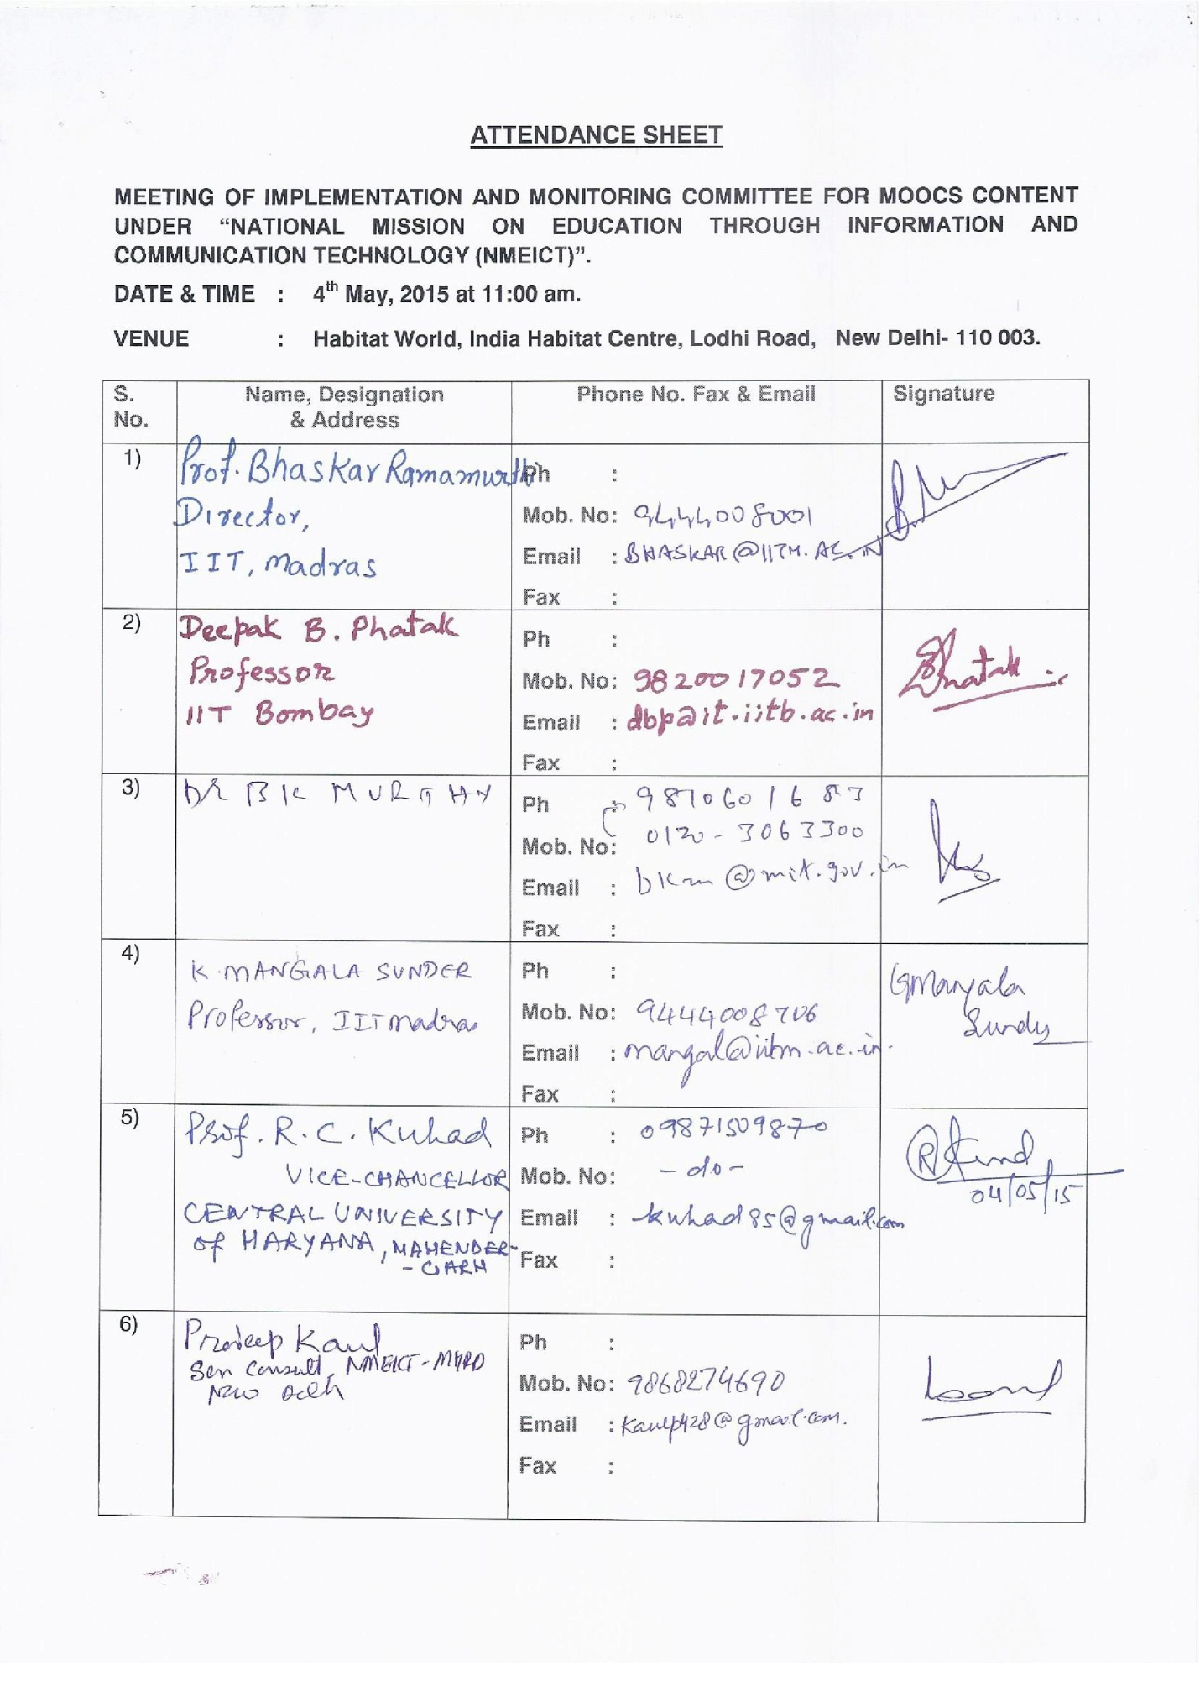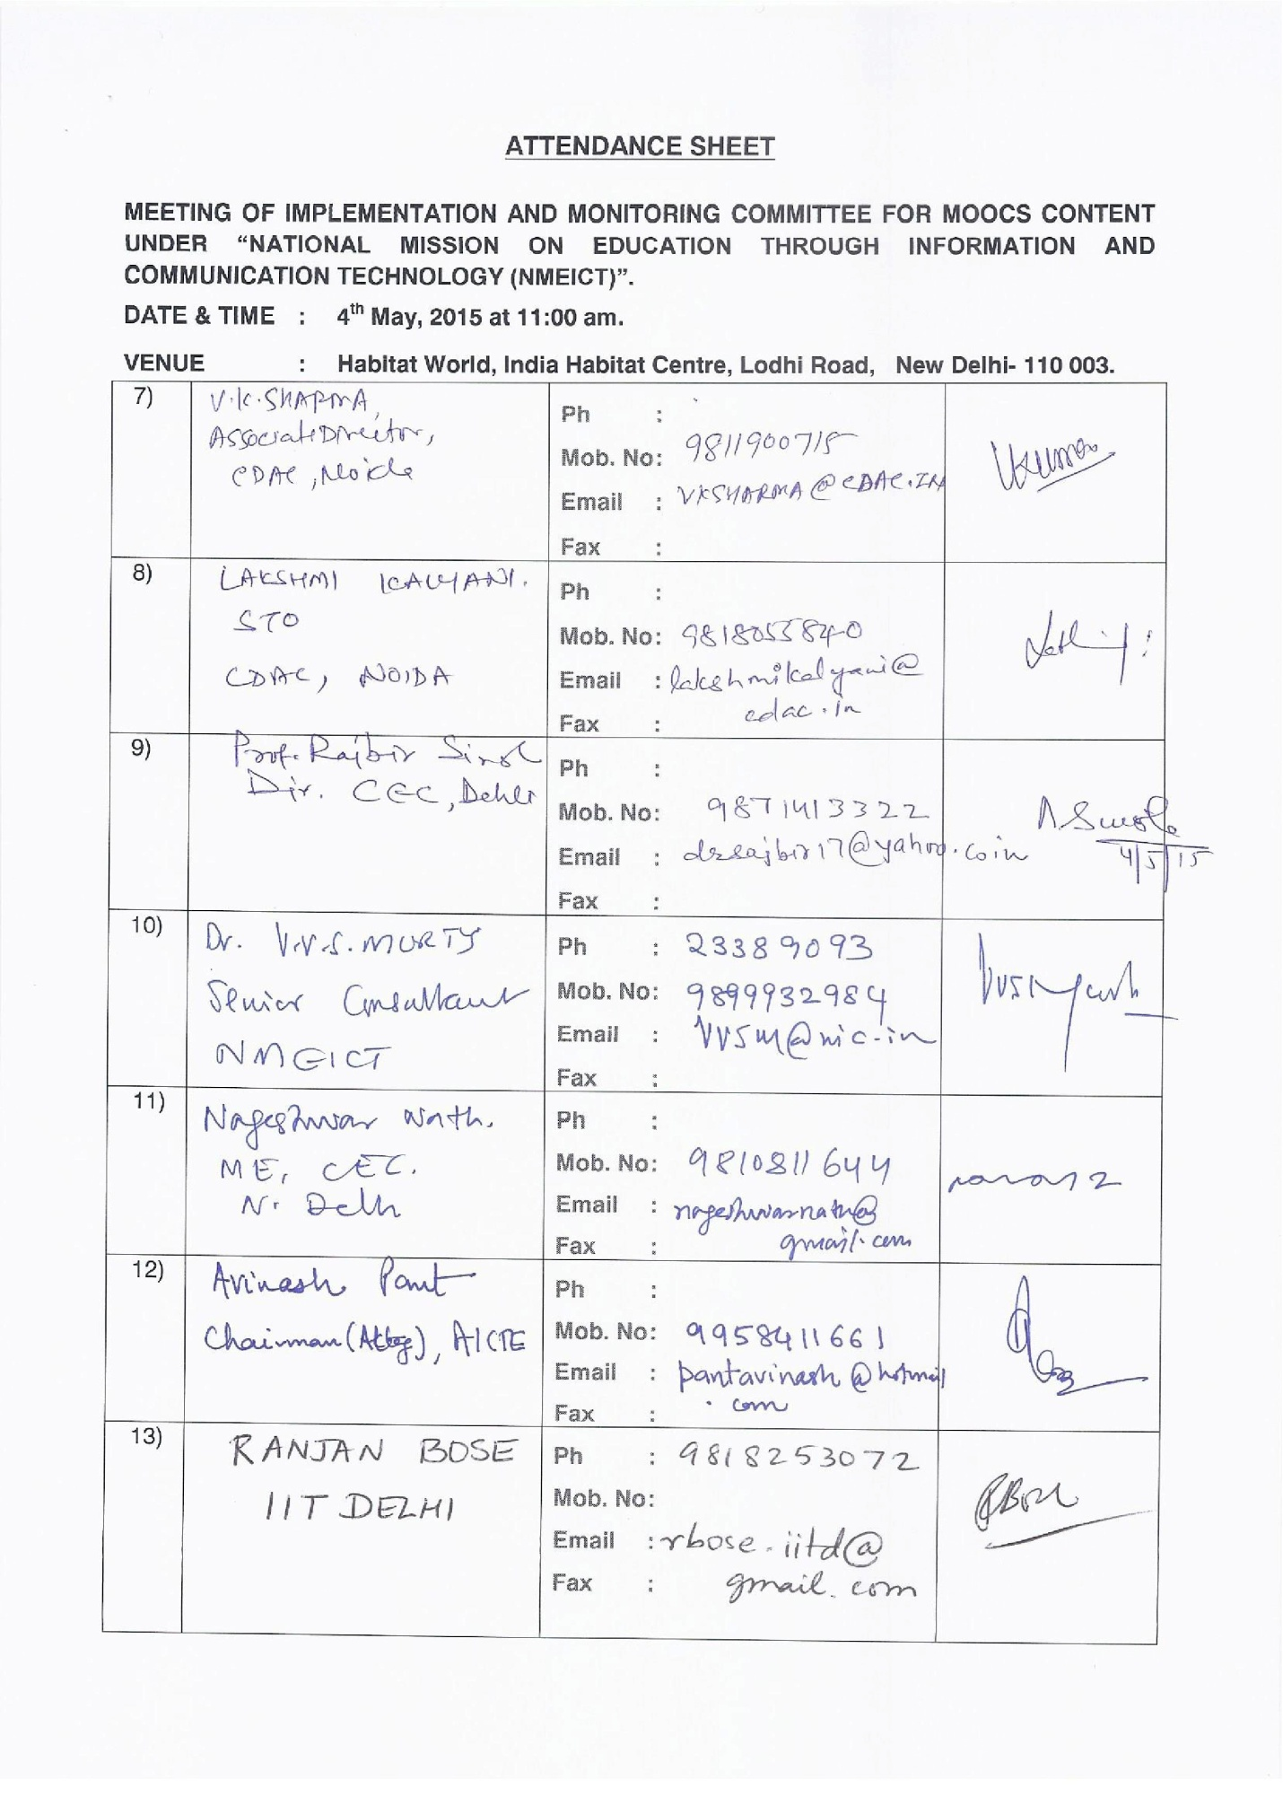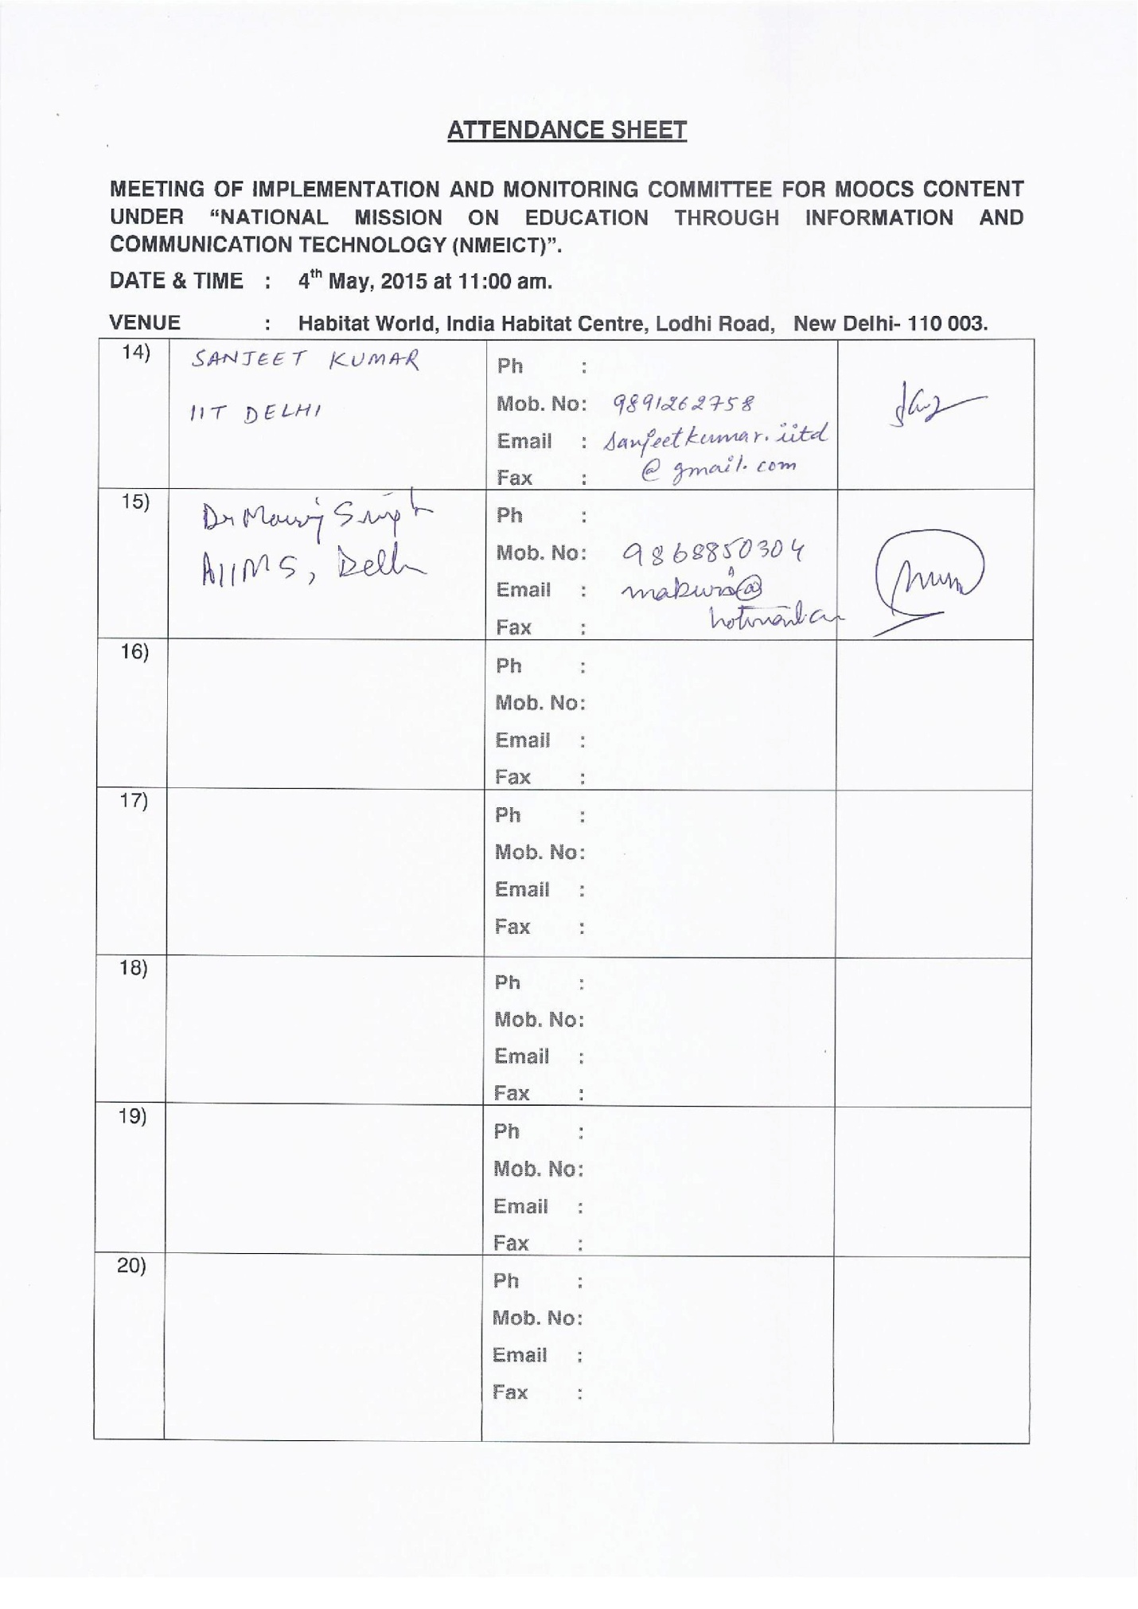

Annexure I

Annexure II

Minutes of the First Meeting of Implementation and Monitoring Committee for MOOCs Content  
Chaired by Prof. Bhaskar Ramamurthi, Director, IIT, Madras  
Held on 6th April 2015 at Shastri Bhavan, New Delhi

First meeting of the Implementation and Monitoring and Committee for MOOCs Content was held on 6th April 2015 under the chairmanship of Prof. Bhaskar Ramamurthi, Director, IIT, Madras and the list of members present in the meeting at Annexure I is given at the end of this Summary.

Chairman initiated the discussions on Terms of Reference of the Committee. The following are the summary of discussions & decisions thereon:

* Ministry is keen to provide MOOCs to leverage/particularly address gap in Higher Education Sector in India as huge gap exists in all disciplines.
* Various offers of MOOCs are currently operational across the world, namely, Coursera, edX, Udacity, Google, FutureLearn to suggest a few, enabling students to access content freely. Most of them administer the programme with a declaration of honour code by participants,
* The present Committee can coopt members or form sub-committees as per requirements of the Committee, and Committee would like to have its meetings in Delhi as most of the members are from Delhi and the surrounding area.
* SWAYAM Platform committee chaired by Prof. S. V. Raghavan will address the issues of provision of requisite hardware and software platform to provide very high concurrency, and provision of requisite tools to operate smoothly various MOOCs offerings. Till such time as the platform becomes available, MOOCs may continue to be offered on alternative platforms adopted by various institutions.
* It may not be feasible to dynamically shift and use multiple platforms for MOOCs operations – For, example, NPTEL is offered on Google platform and IITB is offering courses on edX running on Amazon, and dynamic exchange of platforms may not be feasible. However, given the cluster and the software tools most versions of MOOC courses prepared under the ongoing programmes will be shifted with technical assistance from CDAC and other software groups to the Swayam Platform when needed.
* Wide variations in curricula exist across the universities, which needs to be taken into account while offering MOOCs to students.
* In lieu of face-to-face learning by students, MOOCs employs online forums and moderated discussions with sufficient number of mentors who have the subject expertise. This will also permit courses with slight variations from the proposed syllabus of the University to be skillfully adopted by the teachers of those Universities. Also equivalence of credits to be assigned to learners taking online examinations must be carefully examined so as to derive due benefits of efforts put in while learning e-Content.
* As the technologies for offering MOOCs is changing rapidly, the platform is required to be constantly upgraded to meet the changing requirements
* It has been mentioned that IIT Madras was proposing to partner with Anna University for experimentation with MOOCs to cater to the requirements of its 550 affiliated colleges as per the curriculum of the University. The results of the experiment will be made available to the Committee as soon as it is conducted.
* Paramedical/Para-clinical/skill development courses require due attention for development using MOOCs with specific practical orientation which could be provided at identified model hospitals.
* As per the current statistics of learners/students, arts and humanities’ streams have maximum enrolment of 47% in comparison with engineering (17%) and accordingly due importance for preparation and delivery of MOOCs in these disciplines needs to be given.
* Efforts need to be put in for involving maximum number of universities and faculty members to prepare and offer MOOCs in order to bridge the gap existing in the Higher Education Sector as aspirants are more and educational opportunities are less.
* MOOCs will also be useful in School Education Sector. Accordingly, opinions and suggestions of course development experts for the Committee from experts in CBSE, NCERT, NIOS, etc. may need to be taken at a later stage. Initially, the committee will focus on higher education.
* The members of the Committee from respective domains are requested to identify faculty and courses that can be offered in the short term, and inform the Committee within two weeks, for working out time schedule for the development and delivery of MOOCs in the respective areas. A mail in this regard will be sent to all members.
* Chairmen of UGC and AICTE would be approached for necessary steps to encourage recognition and provision of credits for MOOCs in the relevant areas. UGC would also be invited to nominate an officer in this regard.
* There are several issues of self sustenance in the offering of MOOCs, such as up-gradation of course content, conduct of examination and award of certification with due credits. Initially, new MOOC course will have to be funded in project mode for development of the self-sustaining models in this regard.
* Data integrity to be maintained and ownership of content and IPR should be with the Ministry/professor and institutions offering the course.
* For language transcription and dubbing, empanelment of appropriate agencies has to be done to have them on board.
* Next meeting of the committee has been fixed for 4th May 2015.
* The meeting ended with a Vote of Thanks to the Chair.